Coach Connect: Implementation Plan
Oct 22, 2026 · @Ghost

1. Project summary and overview
Coach Connect is a subscription mobile app (iOS and Android) where clients talk to independent coaches by audio or video call and chat, and every consented call ends with an AI-written summary and action items for both sides. A web admin panel lets the operations team manage users, coaches and subscriptions.
Item | Detail
Project name | Coach Connect
Platforms | React Native mobile app (iOS + Android), Next.js web admin panel, NestJS backend
Business model | Platform subscription (monthly or yearly) sold through in-app purchase
Primary users | Clients (subscribers), Coaches, Support staff, Admins
Delivery approach | Phased MVP: 1-to-1 calls, chat, AI summary and admin first; group calls and scheduling later
Problem. Independent coaches run sessions across WhatsApp, Zoom and payment links. Clients lose notes, coaches chase payments, and there is no single record of sessions.
Solution. One app that handles subscription, calls, chat and session notes in one place. The AI summary turns every call into a durable record: what was discussed, and who has to do what next.
Constraint driving the design. The project must be deployable at zero hosting cost for the first project. The only unavoidable costs are the Apple Developer fee, the Google Play fee and a few dollars of LLM usage (section 2 and section 10).

2. Goals and success metrics
The MVP succeeds if a subscribed client can reach a coach, talk, and receive a correct summary with action items, all at $0 monthly hosting cost. Targets below are proposed starting points to confirm with the client.
Goals
- Replace WhatsApp, Zoom and payment links with one app for subscription, calls, chat and notes.
- Make every consented call produce a usable record (summary, transcript, action items) without manual work.
- Give operations one panel to manage users, coaches and subscriptions, with instant ban enforcement.
- Ship the first version on free tiers only; the only fixed costs are the store fees.
Metric | Target | How it is measured
Call connect time (ring accepted to audio flowing) | p95 under 5 s on a normal mobile network | Client timestamps sent to the backend on each call
Call setup success | 98% or higher of accepted calls reach ACTIVE | Call state log in Postgres
Chat delivery (sender to recipient online) | p95 under 1 s; zero duplicates | Server sequence numbers and idempotency-key collisions
Summary turnaround | p95 under 5 min after a 30 min call ends | Queue job timestamps
AI pipeline success rate | 95% or higher of consented calls reach READY | Summary status counts (feeds the admin KPI)
Ban enforcement | Active sockets and call closed within 5 s | Ban action timestamp vs socket disconnect event
Subscription sync | Access changes within 60 s of a store event | Webhook receipt vs entitlement update
Stability | 99% or higher crash-free sessions | Sentry
Hosting cost | $0 per month | Provider invoices
Variable AI cost | Under $0.01 per consented call-minute after free credits end | Per-job usage logged with each summary
Speech-to-text is billed per track, so a two-person call costs two audio minutes per call minute. At the quoted Nova-3 rate of about $0.0043 per audio minute, that is roughly $0.009 per call minute before any free credit and before trimming silence.

3. Technical details: final stack, previous choices and why they changed
The final stack keeps what the client asked for (React Native, NestJS, Next.js, Socket.io, RevenueCat, Postgres) and changes only the parts that were technically wrong, too costly to run, or incompatible with the zero-cost goal. Where the client explicitly requires something custom, it stays; the changes below are choices between options.
Area | Final decision | Previous (original plan) | Why it changed
Mobile app | React Native CLI (bare), TypeScript | React Native | PushKit, CallKit and Android ConnectionService need native code in AppDelegate and the manifest; Expo Go cannot run them
Media / calling | LiveKit: Cloud free during build, self-hosted for production | Custom WebRTC with a Mediasoup SFU | Mediasoup needs its own signaling, recording, reconnection and UDP hosting. LiveKit provides these, has an RN SDK and per-track recording. Mediasoup stays as the fallback if the client insists on custom
Call signaling | Socket.io carries call states only (ring, accept, decline, cancel); LiveKit handles media signaling and ICE restarts | Socket.io + Mediasoup signaling, ICE restart over STUN/TURN | An SFU is not peer-to-peer; TURN is not on the client-to-SFU path, and ICE restart is not automatic
Incoming-call push | iOS: direct APNs VoIP push into CallKit. Android: FCM high-priority data message into ConnectionService / full-screen intent | One "VoIP push" via CallKit / FCM | FCM cannot deliver PushKit pushes. iOS kills apps that receive a VoIP push and do not report a call immediately
Chat transport | Socket.io, message saved to Postgres then acked; server sequence numbers; since_seq catch-up | Socket.io, ack after Postgres write | Same core. Added ordering and catch-up so offline clients recover without gaps
Offline storage (mobile) | SQLite (op-sqlite) for outbox and chat cache; Keychain/Keystore for tokens | MMKV queue | MMKV is key-value, not a database. Tokens must not sit in plain storage
Backend | NestJS + Prisma (TypeScript) | NestJS | Prisma gives typed schema and migrations for one developer
Database | PostgreSQL: Supabase free for pilot, Neon free for dev | Postgres | Render's free Postgres expires after 30 days. Used as plain Postgres only, no vendor lock-in
Queue and cache | pg-boss on Postgres for the MVP; Redis added when a second API instance is needed | Redis / Postgres for revocation, queue unspecified | One instance needs no Socket.io adapter, and Postgres can hold the ban flag and jobs. Render's free Key Value loses data on restart. Revised from my earlier "Redis required" advice
File storage | Cloudflare R2 (S3-compatible API) | Not specified | 10 GB free with no egress fees; presigned uploads for images, tracks go straight in
Recording | Per-participant audio tracks, never merged | Merge with FFmpeg, then diarize | Separate tracks give exact speaker identity and drop FFmpeg and diarization
Speech-to-text | Deepgram Nova-3 per track (free credit), CPU faster-whisper as the fallback | Deepgram or Whisper API on merged audio | Cheaper and more accurate speaker labels. Fallback removes the dependency on the credit
LLM | One provider: a current Claude Haiku-class model (ID in an env var). Gemini free tier for development only | claude-3-5-sonnet or Gemini | claude-3-5-sonnet is retired; "either/or" is not a spec. Claude has no free tier beyond a one-time trial credit
Subscriptions | RevenueCat, webhook as trigger then re-fetch subscriber by REST | RevenueCat webhooks | Out-of-order and missing events (billing issue, product change, uncancellation) corrupt state otherwise
Auth | Native Google/Apple SDK ID tokens verified by the server; refresh rotation with hashed per-device sessions | Email/password, Google, Apple OAuth with access + refresh JWT | Enables instant revocation and the "active devices" view
Admin panel | Next.js built as a static export, served by the NestJS service; httpOnly cookies, separate issuer, 2FA for ADMIN | Next.js with JWT role claims | One origin and one free service instead of two; closes the localStorage-token risk
Hosting | Render free web service for API + admin during build; one VM for production | Not specified | See section 10: Render free is not meant for production and has no UDP
Monitoring and CI | Sentry free, GitHub Actions for backend and admin; iOS built locally in Xcode | Not specified | Free tiers; macOS CI minutes are the scarcest
Dependencies
Package group | Packages
Mobile: calls | @livekit/react-native, @livekit/react-native-webrtc, livekit-client, react-native-callkeep, react-native-voip-push-notification
Mobile: push and auth | @react-native-firebase/app, @react-native-firebase/messaging, @notifee/react-native, @react-native-google-signin/google-signin, @invertase/react-native-apple-authentication
Mobile: app | socket.io-client, @tanstack/react-query, zustand, react-navigation, react-native-purchases, react-native-keychain, op-sqlite, react-native-image-picker, @sentry/react-native
Backend: core | @nestjs/* (config, jwt, passport, websockets, platform-socket.io, throttler, swagger), prisma, @prisma/client, socket.io, class-validator, argon2, otplib
Backend: integrations | livekit-server-sdk, pg-boss, @aws-sdk/client-s3 and its presigner (R2), firebase-admin, @parse/node-apn, @deepgram/sdk, @anthropic-ai/sdk, @sentry/node
Admin | next, react, tailwindcss, @tanstack/react-query, @tanstack/react-table, a chart library for the analytics cards

4. Users and roles
Four roles exist. Client and Coach use the same mobile app (the role decides which screens appear); Support and Admin use the web panel only. Assumption to confirm: coaches are created or approved by an Admin, not self-registered.
Role | Who | Platform | Can do | Cannot do
Client | Subscriber who pays for access | Mobile | Register, subscribe, browse coaches, call and message, consent to recording, read own summaries, tick action items, delete own account | Call without an active subscription; see other clients' data
Coach | Approved independent coach | Mobile | Set availability, receive and make calls, chat, consent to recording, read and edit action items of own calls | Change subscriptions or ban users
Support | Operations staff, read-only | Web admin | View users, coaches, call logs and AI summaries; every transcript view is audit-logged | Ban, unban, override subscriptions, edit anything
Admin | Operations lead | Web admin (2FA required) | Everything Support can, plus ban and unban, subscription override, coach approval and profile edit, handle abuse reports, edit action items | Nothing is hidden from the audit log
Role enforcement. Roles live in the JWT claims and are re-checked against the database on every admin write. Admin tokens use a different issuer and audience than mobile tokens, so a mobile token can never open the panel.

5. Core user flows
There are five flows. Each lists the corrected behavior, not the original wording.
Flow 1: Sign-in and subscription gating
- The user signs in with email/password, or with the native Google or Apple SDK; for social sign-in the app sends the ID token and the server verifies it.
- The server issues a 15-minute access JWT and a refresh token, stored hashed in a per-device sessions table. Refresh tokens rotate on every use; a reused one revokes the whole session.
- The app calls Purchases.logIn(userId) so RevenueCat uses our user ID, then shows the paywall if there is no active entitlement.
- RevenueCat sends webhooks (INITIAL_PURCHASE, RENEWAL, CANCELLATION, UNCANCELLATION, BILLING_ISSUE, PRODUCT_CHANGE, EXPIRATION). The server treats each as a trigger only: it deduplicates by event ID, re-fetches the subscriber from the RevenueCat REST API, and stores the status.
- Statuses are ACTIVE, TRIAL, GRACE_PERIOD, CANCELLED_ACTIVE (still has access until expiry) and EXPIRED. Only EXPIRED and never-subscribed users are blocked.
- To call, the app asks the server for a short-lived call join token. The server checks the subscription and refuses the token if access is gone; the UI also disables the call buttons.
Flow 2: Making and receiving a call
- The caller taps Call on a coach. The server checks the subscription, creates a call in RINGING and sends a push to every device of the receiver: APNs VoIP on iOS, an FCM high-priority data message on Android.
- The receiver's phone shows the native incoming-call screen (CallKit or full-screen intent), even when the app is killed or locked.
- Accept: the app starts, loads tokens from Keychain, refreshes if expired, joins the LiveKit room with its join token, and the call becomes ACTIVE. The other devices of that user stop ringing.
- Decline, busy, caller cancel or a 30-second timeout end the call as DECLINED, BUSY, CANCELED or MISSED; a missed call sends a notification.
- If the network drops, LiveKit reconnects and restarts ICE automatically; after 15 seconds without media the call ends as FAILED.
- Duration is stored by the server when the room closes, never from client timers.
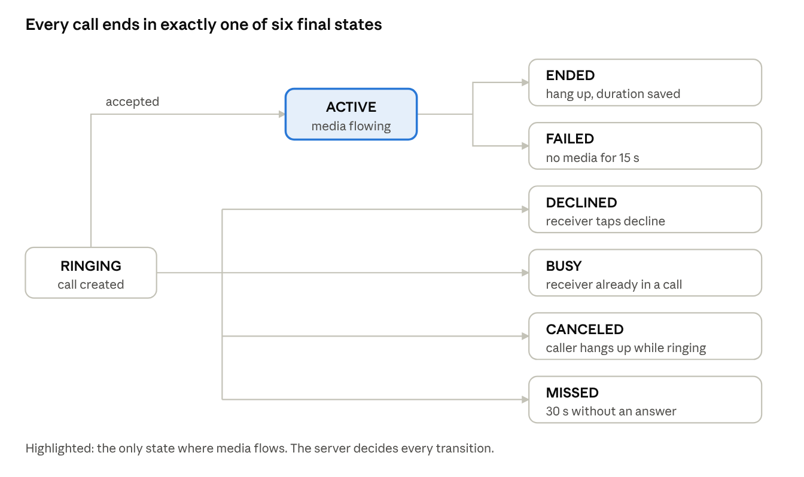
call states · 1 start, 1 active, 6 final
A call leaves RINGING only by the server's decision: accept moves it to ACTIVE, and each other outcome is a final state written to the call log.
Flow 3: Chat
- The sender creates a message with a client-generated UUID and puts it in the local SQLite outbox.
- It is sent over Socket.io. The server saves it to Postgres under a unique (sender_id, client_msg_id) index, assigns a sequence number and acks the sender, so retries never duplicate.
- If the recipient has no active socket, the server sends an FCM or APNs push. Images upload first to R2 through a presigned URL, then the message carries the file reference.
- After a reconnect the client asks for everything after its last seq; delivered and read receipts and typing indicators travel as events.
Flow 4: Recording, transcript and AI summary
- When a call is accepted, every participant sees a consent prompt. Recording is opt-in per call and starts only when all current participants agree.
- Each participant's audio is recorded as its own track. If someone declines, the call continues with no recording and no summary; a late joiner triggers consent again.
- When the call ends, a pg-boss job transcribes each track with timestamps, then merges them by time. Track owner equals speaker, so action items are attributed exactly.
- The transcript goes to the LLM with a fixed JSON schema (executive summary, key topics, action items per person). Invalid output is retried once, then marked FAILED.
- The result is saved, both users get a push, and the summary appears in the app and the admin panel. Coaches can edit action items; clients tick them off. Raw audio is deleted after transcription.
Flow 5: Admin, roles and instant ban
- Admin or Support signs in with an httpOnly-cookie session; Admin also completes 2FA.
- Support has read-only access; every transcript view writes an audit entry.
- When an Admin bans a user, the server sets is_banned, closes the user's sockets, removes the user from any LiveKit room, revokes all refresh tokens and deletes push tokens. Every request and every socket handshake also checks the ban flag, so an unexpired access token stops working at once.

6. Functional requirements
Requirements are numbered so they can be traced to tasks. MVP items are phases 1 to 4; "Later" items are in section 9.
Mobile app (Client and Coach)
ID | Requirement | Phase
M1 | Sign up and sign in with email/password, Google, Apple; email verification; password reset; silent token refresh | 1
M2 | Paywall with monthly and yearly plans, restore purchases, subscription state in settings | 1
M3 | Coach directory with search, specialty filter and availability; coach profile with bio, specialties and Call / Message actions | 1
M4 | 1-to-1 audio and video calls: mute, camera on/off, flip camera, speaker, end call, reconnect handling | 2
M5 | Native incoming-call UI on locked or killed app (CallKit, ConnectionService), with ring timeout and cancel | 2
M6 | Permissions onboarding for microphone, camera and notifications | 2
M7 | Recording consent prompt for every participant; recording only after all agree | 3
M8 | Conversation list and chat room: text, images, typing indicator, read receipts, offline outbox, connection banner | 3
M9 | Call history, transcripts, AI summaries and checkable action items; coach can edit items | 4
M10 | Report and block a user; blocked users list | 4
M11 | Settings: account details, notification preferences, subscription, account deletion (revokes Apple token, anonymizes data) | 4
M12 | Coach mode: availability toggle, client list, call and chat inbox | 2
Mobile screens
- Splash and auth loading
- Login and registration, password reset and email verification
- Permissions onboarding
- Paywall
- Coach directory and coach profile
- Inbox (conversation list) and chat room
- Native incoming-call UI and in-app active call screen (audio or video, controls, consent banner)
- Call history with AI summary and action items
- Profile and settings (including blocked users and delete account)
Web admin panel (Admin and Support)
ID | Requirement | Phase
A1 | Login with httpOnly cookies, 2FA for Admin, role-based access (Admin write, Support read-only) | 1
A2 | User and coach tables: paginated, search, role and status filters, status badges | 1
A3 | Admin actions: ban, unban, subscription override (promotional entitlement through RevenueCat), coach approve and edit | 1
A4 | User detail: profile, active devices, subscription history, call logs | 2
A5 | Call logs with participants, duration, status; drawer with transcript, AI summary and action items | 4
A6 | Analytics: registered users, active subscribers, calls completed, weekly trend, AI pipeline success rate; revenue figures pulled from RevenueCat | 4
A7 | Moderation queue for reports and abuse | 4
A8 | Audit log of every Admin write and every transcript view | 1

7. Architecture
One NestJS service holds the REST API, the Socket.io gateway and the job worker, and serves the static admin panel. It talks to Postgres, R2, LiveKit, RevenueCat, push providers and the AI vendors. This keeps the MVP to a single deployable unit that can move between hosts without code changes.
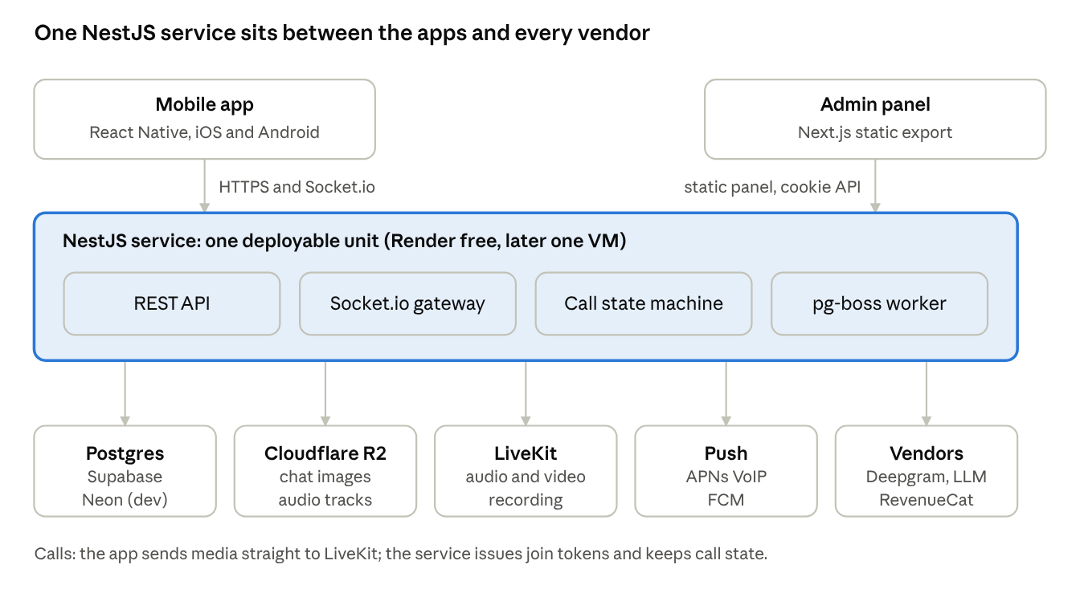
architecture · 1 service, 5 backing systems
Both apps talk only to the NestJS service; it owns state in Postgres and hands media to LiveKit.
Key modules (NestJS)
Module | Responsibility
Auth | Registration, social ID-token verification, JWT issue, refresh rotation, per-device sessions, ban check guard
Subscriptions | RevenueCat webhook controller (idempotent), REST re-fetch, entitlement status, call-token gate
Calls | Call state machine, ring timeout, LiveKit join tokens, push dispatch (APNs VoIP, FCM), room webhooks
Chat | Socket.io /chat namespace, sequence numbers, receipts, presigned image uploads, offline pushes
Recording | Starts and stops per-track recording after consent; stores consent log; uploads to R2
AI pipeline | pg-boss jobs: transcribe each track, merge, summarize, save, notify; retries and failure state
Admin | Cookie auth, 2FA, user and coach operations, audit log, analytics queries, moderation
Core data model (Postgres)
Table | Main fields
users | id, email, role, is_banned, token_version, created_at
sessions | id, user_id, device_id, refresh_hash, last_seen, revoked_at
coach_profiles | user_id, bio, specialties, approved, available
subscriptions | user_id, status, product, expires_at, last_event_id
calls | id, caller_id, room, state, started_at, ended_at, duration_s
call_participants | call_id, user_id, joined_at, left_at, consent
messages | id, conversation_id, sender_id, client_msg_id, seq, body, attachment, created_at
summaries | call_id, status, transcript, summary_json, model, cost_usd
action_items | id, call_id, assignee_role, text, is_completed, edited_by_coach
reports, audit_log, push_tokens | Moderation, admin accountability, per-device push credentials
Architecture rules
- Subscription and ban state live in Postgres; the server reads them on every request and socket handshake (cached in memory for seconds, not trusted from the token).
- Webhooks only trigger a re-fetch; they are never the source of truth.
- The call state machine is server-owned; clients send intents, the server decides transitions.
- Audio is never merged and is deleted after transcription.
- Everything is configured by environment variables and runs in Docker, so moving from Render to a VM changes no code.

8. Non-functional requirements
Category | Requirement
Performance | API p95 under 300 ms for reads; call connect p95 under 5 s; chat delivery p95 under 1 s; app cold start under 3 s on a mid-range phone
Reliability | Messages are never lost or duplicated (idempotency key, server ack, outbox retry). Calls survive network changes for up to 15 s. Failed AI jobs retry and then surface a FAILED state the user can see
Availability | Build phase: best effort, with cold starts accepted. Pilot: one always-on host, with a documented restore from backup
Security: auth | Argon2 password hashes; 15-minute access tokens; rotating hashed refresh tokens; rate limiting on auth and webhook routes; tokens in Keychain/Keystore only
Security: admin | Separate token issuer and audience, httpOnly SameSite cookies, 2FA for Admin, full audit log, transcript views logged
Security: transport and secrets | TLS everywhere; webhook signatures verified; secrets only in environment variables, never in the repo or the app bundle
Privacy | Opt-in recording with a consent log; no recording before all consent; raw audio deleted after transcription; transcript retention period set with the client; a privacy policy naming the AI vendors; vendor settings that do not train on our data
Compliance | Apple: Sign in with Apple beside Google, in-app account deletion, report and block for user-generated content, correct IAP use. Google Play: full-screen intent declaration, foreground service types
Platform | iOS and Android phones; current and previous major OS versions; portrait layout; light and dark mode
Scalability | One instance serves the pilot. Scaling out adds Redis for the Socket.io adapter and moves queues off Postgres; media scales by adding LiveKit nodes
Observability | Sentry on app and backend; structured logs with call and request IDs; per-job AI cost and duration stored
Accessibility | Dynamic type, screen reader labels on call controls, minimum 44 pt touch targets
Maintainability | TypeScript everywhere, one monorepo, migrations through Prisma, lint and tests on every push

9. Out of scope
The MVP deliberately leaves these out so it can ship on free tiers and be tested properly.
Out of the MVP (candidates for later phases)
- Group calls of up to 4 people (the data model allows it; the ring, invite and late-join rules are not yet defined)
- Session scheduling, calendar and reminders; the MVP supports instant calls only
- Payments from clients to coaches and coach payouts; the subscription is a platform fee only
- Coach ratings and reviews
- Audio playback of calls, video recording, and live captions
- Multi-language transcription beyond the languages agreed with the client
- Group chat, voice notes, message editing and deletion
- Web client for clients and coaches; Android tablet and iPad layouts
- Advanced analytics, exports and revenue reporting beyond the KPI cards
- Automatic content moderation of chat; the MVP has report, block and a manual queue
Not being built at all
- A custom media server, if LiveKit is accepted (Mediasoup remains only as a fallback)
- Peer-to-peer calling, which cannot record and does not scale past two people
Needs a client decision before phase 2
- Does the subscription give unlimited calls, or is there a minutes cap? Each minute costs STT and media bandwidth.
- Is chat gated by the subscription, or only calls? Does a coach need a subscription?
- What exactly is a "group"? Who rings, who can invite, and who may end it?
- How are coaches onboarded and paid, if at all, through the platform?

10. Deployment
Render is a good home for the API and admin panel while you build and demo, but it cannot be the whole production setup: its own docs say free instances are not for production applications, and its free tier has no UDP support listed for a media server. The plan below uses Render where it fits and names what must live elsewhere. Figures are from the Render free-tier page, read on 22 Oct 2026.
Render free fact | Effect on Coach Connect | What we do
750 free instance hours per workspace per month | One always-on service uses about 744 hours in a 31-day month; a second service would run out of hours | Run exactly one web service: NestJS API, Socket.io, job worker and the static admin panel together
Spins down after 15 min without inbound traffic; cold start about one minute | A call started after idle would hang for about a minute | Open Socket.io connections keep it awake while users are online; add an uptime-monitor ping every 10 min and treat the setup as pilot-only
"Do not use them for production applications"; may restart at any time | No uptime promise | Pilot on Render only with the client's agreement; production moves to a VM (below)
Free Postgres expires after 30 days and is deleted after a 14-day grace period; 1 GB, no backups | Unusable for this project | Do not use it. Use Supabase or Neon free Postgres
Free Key Value (Redis) loses all data on restart | Cannot hold jobs or bans | Not used in the MVP; pg-boss and Postgres replace it
No free background workers or cron jobs; ephemeral disk | No separate worker; no local files | Worker runs inside the API process; all files go to R2
No UDP or arbitrary ports listed for free web services | A media server cannot run here | LiveKit Cloud free for the build; self-hosted LiveKit on a VM for production
Outbound SMTP ports 25, 465, 587 are blocked | Email verification and password reset cannot use SMTP | Send email through an HTTP email API; provider to be chosen
Free-tier bandwidth and build-minute amounts are not on that page | Unknown overage point | Check the Render pricing page before launch; with no payment method, overage suspends services instead of billing
Environments
- Build and staging ($0). One Render free web service; Neon free Postgres for dev branches; Supabase free Postgres for the pilot data set; LiveKit Cloud free; Cloudflare R2; Deepgram free credit; Gemini free tier for LLM development; RevenueCat sandbox; Sentry free.
- Pilot and production (about $0 to a few dollars). One VM running Docker Compose: API, LiveKit server with egress, Caddy for TLS. Oracle's Always Free ARM VM is the free option but was reportedly cut to 2 OCPU and 12 GB in June 2026 (InfoQ), and capacity is unreliable; keep a small paid VPS as the fallback.
Database choice. Supabase free gives 500 MB, 2 active projects and pauses after 1 week of inactivity, which an active pilot avoids. Neon free gives 1 GB per project with 100 CU-hours and suspends after 5 minutes idle; a constantly polling job queue would burn those hours, so Neon is for dev branches and Supabase for the always-on pilot. Use direct or session-mode connection strings with pg-boss and Prisma. R2 gives 10 GB, 1 million write and 10 million read operations per month and no egress fees.
CI/CD
- Push to main runs lint, tests and prisma migrate deploy in GitHub Actions on a Linux runner (private repos get 2,000 free minutes a month).
- Render auto-deploys from the same branch; /health is the health check and the uptime-monitor target.
- iOS builds are made locally in Xcode and uploaded to TestFlight, because macOS runner minutes are the scarcest; Android builds run on a Linux runner and go to Play internal testing.
- Secrets live only in the Render dashboard: database URL, JWT secrets, RevenueCat API key and webhook auth, LiveKit URL and keys, R2 keys, FCM service account, APNs key, Deepgram key, LLM key and model ID, Sentry DSN.
What still costs money
Item | Cost | Needed for
Apple Developer Program | $99 per year | PushKit, CallKit, TestFlight, in-app purchase
Google Play developer account | $25 one time | Android release
LLM summaries | cents per call after free credits | Claude Haiku-class model; Gemini free tier only for development
Domain name (optional) | about $10 per year | Branded API URL; a free subdomain works for the pilot
RevenueCat | free up to $2,500 monthly tracked revenue, then 1% (pricing) | Subscriptions

11. Step-by-step implementation plan
The build takes about 12 weeks for one developer, in six phases. Durations are estimates to adjust once the open client decisions in section 9 are answered. Each phase ends with a gate: do not start the next phase until it passes.
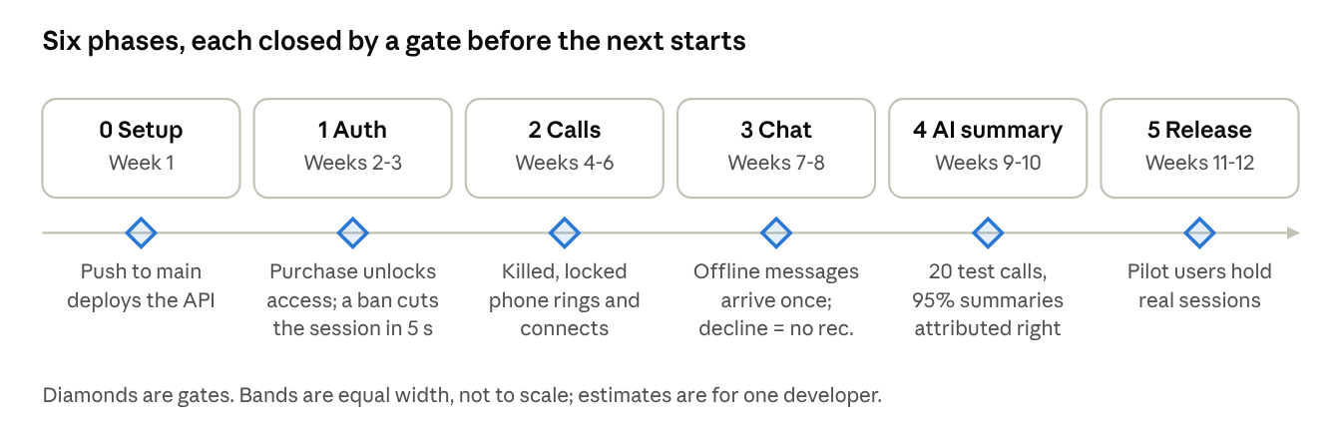
roadmap · 6 phases, 6 gates
Phase 0: Setup and decisions (week 1)
- Get the four client answers from section 9 (minutes cap, gating scope, group definition, coach onboarding).
- Create accounts: Apple Developer, Google Play, Firebase (FCM), RevenueCat, LiveKit Cloud, Supabase, Neon, Cloudflare R2, Deepgram, Render, Sentry, GitHub.
- Create the monorepo with mobile, backend and admin folders; initialize React Native CLI, NestJS and Next.js; add Docker, lint, formatting and a GitHub Actions workflow.
- Write the first Prisma schema (users, sessions, subscriptions, calls) and deploy an empty NestJS app with /health to Render.
- Gate: a push to main deploys the API; the app can call /health on a real phone.
Phase 1: Auth, subscriptions, directory, admin basics (weeks 2 to 3)
- Backend: email/password, Google and Apple ID-token login, refresh rotation, sessions table, ban guard, email verification and reset through an HTTP email API.
- RevenueCat: products, entitlement, sandbox purchases, idempotent webhook controller with REST re-fetch, call-token gate.
- Mobile: splash, login, paywall, restore purchases, coach directory and profile, settings shell.
- Admin: login with cookies and 2FA, user and coach tables, ban and unban, subscription override, coach approval, audit log.
- Gate: a sandbox purchase unlocks access; an Admin ban logs the user out within 5 seconds.
Phase 2: Calling (weeks 4 to 6)
- Backend: call state machine, 30-second ring timeout, LiveKit join tokens, room webhooks, APNs VoIP and FCM data-push dispatch, multi-device ring and cancel.
- Mobile: permissions onboarding, active call screen, CallKit and ConnectionService integration, cold-start accept (headless runtime, Keychain tokens), audio routing and interruption handling, coach mode and availability.
- Test matrix: killed app, locked screen, Wi-Fi to mobile data switch, Bluetooth, a phone call arriving during a call, both platforms.
- Gate: a call from the app to a killed, locked phone rings and connects on iOS and Android, and survives a 10-second network drop.
Phase 3: Chat and recording consent (weeks 7 to 8)
- Chat: Socket.io /chat, idempotent saves, sequence numbers and since_seq catch-up, receipts, typing, presigned R2 image upload, offline pushes.
- Mobile: inbox, chat room, SQLite outbox, connection banner.
- Recording: consent prompt and consent log, per-track recording started only after all agree, upload to R2.
- Gate: 200 queued offline messages arrive once, in order; a decline produces no recording.
Phase 4: AI summary, moderation and admin reporting (weeks 9 to 10)
- pg-boss pipeline: per-track transcription, timestamp merge, LLM call with JSON schema, retry then FAILED, push on READY, delete raw audio.
- Mobile: call history, summaries, checkable action items, coach editing; report, block and blocked list; account deletion.
- Admin: call logs with transcript and summary drawer, analytics cards (including AI success rate), moderation queue.
- Gate: 20 real test calls produce correct, correctly attributed summaries at 95% or better success and within the target turnaround.
Phase 5: Hardening and release (weeks 11 to 12)
- Move the production backend and self-hosted LiveKit to the VM with Docker Compose and Caddy; keep Render as staging; set up database backups to R2.
- Soak and load tests: 4 hours of continuous calls, 50 concurrent chat users, restart recovery.
- Security pass: rate limits, webhook signatures, admin 2FA enforced, secrets review, privacy policy and consent copy approved by the client.
- Submit to TestFlight and Play internal testing, fix review feedback, release to the pilot group.
- Gate: pilot users complete real coaching sessions; all success metrics in section 2 are reported weekly.
Risks and mitigations
Risk | Impact | Mitigation
Killed-app call accept on iOS and Android is the hardest native work | Phase 2 slips | Spike it in the first week of phase 2 on real devices; do not defer it
Free-tier limits: LiveKit Cloud free allows 60 track-recording minutes a month; Deepgram credit expiry not confirmed on Deepgram's own page | Recording or STT stops mid-pilot | Use Cloud only for build; self-host LiveKit for the pilot; confirm Deepgram terms; keep the CPU Whisper fallback ready
Render free cold starts and restarts | Slow first call after idle | Uptime ping; move to the VM before real users
Oracle free VM capacity or terms change | No production host | Keep a small paid VPS as the fallback; the stack is portable Docker
App Store review (in-app purchase, user content, account deletion) | Release delay | Build report, block, deletion and Sign in with Apple in phases 1 to 4, not at the end
Recording and AI privacy | Legal and trust exposure | Consent log, opt-in only, audio deleted after transcription, privacy policy naming vendors
One developer, 12 weeks | Schedule risk | Hold the scope in section 9; group calls and scheduling stay out

Sources
Pages opened on 22 Oct 2026. Free-tier terms change often; recheck each before launch.
- Render: Deploy for Free and Render FAQ
- LiveKit Cloud quotas and limits
- InfoQ: Oracle Cloud free tier limits (Jul 2026)
- RevenueCat pricing
- Neon pricing and Supabase pricing
- Cloudflare R2 pricing
- GitHub Actions billing and Sentry pricing
- Third-party summaries, not the vendors' own pages: Deepgram pricing (diyai.io) for the $200 credit and $0.0043 per minute, and Anthropic free tier (pricepertoken.com) for the one-time trial credit. Confirm both on the vendors' sites.

